VOTING IS REALLY IMPORTANT.
HERE’S HOW TO DO IT

Copyright 10/25/18 by Susan Senator
All rights reserved

ALL ABOUT VOTING

- Voting is making choices. Voting is a wonderful thing to do if you are grown up. Voting is VERY IMPORTANT FOR ANYONE LIVING IN THE UNITED STATES.

- The choices are for different people who want to be in charge in Massachusetts. These are called Elected Officials.

- The choices are also for some rules that all people must follow. These are called Questions.

WHAT WILL HAPPEN AT THE VOTING PLACE?

We go into the building. At the first table, ____________ says his name SLOWLY and clearly

_____________________ says his address SLOWLY and clearly

_____________________ takes the paper ballot and goes into a booth
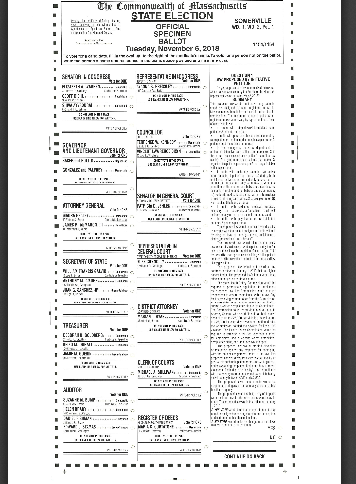

________________relaxes and takes a deep breath. _____________moves calmly and SLOWLY.

________________uses the pen to color in ONLY ONE CIRCLE: That is how you vote!

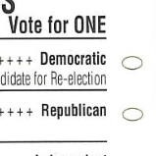

WHAT IS ON THE BALLOT TODAY?

People who want to be in charge of [your state], and also Rules for us to follow.

__________________ is probably a DEMOCRAT/REPUBLICAN/INDEPENDENT because: ______________________________________________________________________________________

[Note: I believe a guardian/parent/friend can guide the individual the way you would guide anyone who asks. Do not be ashamed to advise voting for the party that is in the individual’s best interest. Here is an example: Nat likes living in an apartment and going to his day program. DEMOCRATS believe this is a good thing and they spend money on it. So Nat should vote ALL DEMOCRAT because Democrats make those kind of rules and spend money on those kind of things.]

Nat’s family are all Democrats.
What are you going to be? Republican or Democrat?

[Note: Again, it is very typical for individuals to want to know how their parents and families vote, and for parents to guide them thus. In Nat’s case, it is the Democrats who will preserve the funding for his programs, for the life he lives.]

____________________________________________can color in a circle for each new box:

- Candidate 1 believes that _____________________________________________________.
[Note: Make a one sentence statement that would make sense and sums it up in a way relevant to the individual.] For example: Elizabeth Warren makes rules that allow Nat to live in his own apartment. Geoff Diehl would take that rule away.]

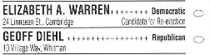
Fill in just one!

2. Jay Gonzalez/Palfrey Democrat OR Charlie Baker/Polito Republican
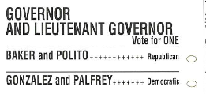

Ballot Questions. There are 3 Ballot Questions. Color in one circle for each.

Question 1 is about nurses who work in hospitals. Hospitals need to hire more
nurses, or do hospitals need to make nurses work harder to help every patient in need, even if it is hard for the nurse?

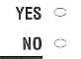

Question 2 is about making elections more fair for people with less money. Or should people with more money be allowed to spend a lot of money to become a leader.

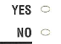

Question 3 is about protecting all people letting them eat where they want, go to movies they want, use bathrooms in restaurants.

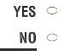
That’s it! Put the paper in the slot of the machine! You did it!

